Introduction
Biometrics are the measurement and analysis of an individual’s unique physical or behavioral characteristics. A biometric system is a technology designed to identify and verify individuals based on these traits. Commonly used identifiers include fingerprints, iris patterns, voice, and facial features. Facial recognition has especially become a widely researched biometric technology, offering a seamless method of authentication. Within the following experiments, facial recognition involves the automated identification of individuals by analyzing facial structures within images. The accuracy of these facial recognition systems can be influenced by various factors which include but are not limited to image quality, resolution, and the presence of image processing filters such as Gaussian blur.
This project investigates two key research questions: How does image resolution affect the accuracy of facial recognition? How does adding a Gaussian blur to the images impact recognition accuracy?
To address these questions, I worked with a biometric face detection system in tandem with the publicly available Caltech Faces Dataset and a facial landmark detection model named Mediapipe FaceMesh. I conducted controlled experiments where I systematically altered the resolution of the input images (50×50, 100×100, 200×200, and 400×400 pixels) and then applied Gaussian blur with varying kernel sizes (3, 5, 7, 9, and 11) to observe their impact on facial recognition accuracy. The results showed that increasing image resolution generally improved recognition accuracy, though the gains became marginal beyond 200×200 pixels. In terms of Gaussian blur, a small amount of blurring with kernel sizes of 3 and 5 actually enhanced recognition performance compared to the baseline of no blurring. The moderate kernel size of 7 achieved the highest accuracy and larger blurs of kernel sizes 9 and 11 remained better than the baseline but did not outperform the mild blur condition. These findings suggest that both image resolution and controlled application of Gaussian blur play meaningful roles in optimizing facial recognition accuracy, offering valuable insights for biometric system development.
Related Work
As a part of my research, I found that my experiment was built on plenty of prior studies that had to do with the various aspects of my project. Al-Nuimi and Mohammed [1] explored facial direction estimation using Mediapipe. However, they focused on trying to implement trigonometric models whereas I focused on recognition accuracy through image degradation and improvement. While both of our studies use Mediapipe’s FaceMesh for landmark detection, my work extends this application to biometric verification, examining how image resolution and Gaussian blur affect recognition outcomes. Similarly, Liu et al. [2] addresses the estimation of generalized Gaussian blur kernels for image deblurring. Reading through this study gave me lots of insightful information as to how Gaussian Blur works. The study works to articulate a system to deblur images that have already been blurred through the Gaussian method. Oppositely, my methods involve purposely applying the blur to photos and recording the usefulness of the blur.
Lee et al. [3] dealt with low-resolution face recognition using convolutional neural networks in environments with multiple people. My study and Lee’s share resolution as a key variable, but my experiment employs classical machine learning classifiers (KNN and SVM). Lee’s study offers a complementary perspective to solutions centered around deep learning. Additionally, Thaman et al. [4] utilized Mediapipe’s FaceMesh for mask detection during the COVID-19 pandemic. Thaman worked to perfect face segmentation, which provided valuable insight into how the Mediapipe works on centralized features like the eyes. Both of our studies showcase the versatility of Mediapipe for facial feature extraction.
Lastly, Matin et al. [5] utilized a weighted score-level fusion system while also combining iris and face recognition modalities. While my system applies score-level fusion as well, it does so by averaging the output probabilities of two facial recognition classifiers rather than working in tandem with fusing different biometric modalities (feature-level fusion). In my research I found countless studies utilizing some level of fusion which shows the importance of combining classifier outputs to improve biometric system performance. Overall, my research adds valuable insight to my project by showing how changes in image resolution and blur affect the accuracy of face recognition using Mediapipe landmarks and popular score-level fusion models.
Methods
The dataset I used in my experiments consisted of a collection of facial images sourced from the publicly available Caltech Faces Dataset from 1999. Each image contained a clear, front-facing portrait of an individual under varying backgrounds and lighting conditions. To evaluate how image changes impact recognition accuracy, I implemented two types of preprocessing: image resolution adjustment and Gaussian blurring. For resolution changes, images were resized to three different dimensions: 50x50, 200x200, and 400x400 pixels. 100x100 pixels served as the baseline measurement and the resolution used for the Gaussian Blur experiments. The resizing process was performed in the get_images image processing file using the cv2.resize() function from OpenCV, where the width and height arguments were set to the experimental resolutions. Outside of the experiment, the images would have needed to be resized anyway; “all training/test images need to be resized to match the same resolutions of the input layers. To avoid image distortion, face images are only scaled down” [3]. Each time, after altering the resolution in the get_images file, the resulting score distribution plots were recorded, and baseline code was run again to ensure no other accidental changes were made.
The next part of the experiment was to test the effect of Gaussian Blur on the system’s performance. This involved applying different intensities of the blur. This was achieved by altering the same get_images file and using the OpenCV function cv2.GaussianBlur(), with kernel sizes of 3, 5, 7, 9, and 11. The baseline for this section of the experiment was captured by making the cv2.GaussianBlur line of code a single-line comment so that no blur is added to the image. A Gaussian kernel is a square matrix that assigns a weighted average to neighboring pixel values, effectively smoothing the image [6]. Kernel sizes must be odd to maintain a central anchor point in the matrix, which serves as the reference pixel during the blurring. An example line of code implemented for the smallest amount of blurring possible was img = cv2.GaussianBlur(img, (3, 3), 0) since 3 is the lowest odd number other than 1, but a 1x1 Gaussian blur matrix would not apply any blurring to the image since the centered pixel would not have any neighboring pixels to average with. Once again, after altering the blurring in the get_images file, the resulting score distribution plots were recorded, and the baseline code with the Gaussian blur line rendered mute was run again to ensure no other accidental changes were made.
For feature extraction, this project opted to use MediaPipe’s FaceMesh library rather than the more commonly used dlib library. I selected MediaPipe because of its real-time processing capabilities and ease of integration. These landmarks were extracted and stored as (x, y) coordinate pairs for use in the recognition phase. This work was done in the get_landmarks file and the FaceMesh module was initialized using the mp_face_mesh.FaceMesh() function. The parameters were set for static image mode, a maximum of one face per image, refined landmarks, and a minimum detection confidence of 0.5. Images were converted from BGR to RGB using OpenCV’s cv2.cvtColor() function before being processed. If landmarks were detected, the first n landmark coordinates were extracted, scaled to the image dimensions, and stored for use in the classification step.
Facial recognition in this project was conducted using two classifiers: K-Nearest Neighbors (KNN) and Support Vector Machine (SVM). The extracted landmark coordinates were used as feature inputs for both classifiers, which each produced a probability score. The main reason I used two classifiers was to implement a score-level fusion technique that was implemented in the main program. Rather than selecting the output of a single classifier, the system averaged the probability scores from both KNN and SVM classifiers using the formula (svm_probability + knn_probability) / 2. The class corresponding to the highest combined score was then selected as the final recognition decision. This score-level fusion approach allows the system to reap the benefits of both classifiers. In the case where score-level fusion was intentionally left out, the main program could be easily adjusted by selecting the probability scores from just the KNN classifier and passing those scores directly into the matching and evaluation process. This bypasses the fusion while preserving the rest of the workflow.
Results
The performance of the biometric system was analyzed by observing the separation between genuine and impostor score distributions across different experimental conditions. In the resolution experiments, reducing the image size below the baseline of 100x100 pixels, such as at 50x50, led to noticeably worse system performance. The lower resolution caused the genuine and impostor score distributions to almost completely overlap, which hurt recognition accuracy. This degradation occurred because at very low resolutions, there may not be enough detail in the images for Mediapipe to reliably locate facial landmarks. Important facial features become too pixelated, making it difficult for the FaceMesh model to extract meaningful landmark points. On the other hand, increasing the resolution to 200x200 pixels improved recognition performance compared to the baseline. Images at this resolution had enough detail for more accurate landmark extraction, resulting in better separation between genuine and impostor scores. Moving up to 400x400 pixels gave only marginal improvements compared to 200x200, suggesting that extremely high resolutions, like 500x500 or beyond, might not provide significant additional benefits. While higher resolution allows Mediapipe to detect points more precisely and might even enable the use of more landmarks without losing accuracy, it also introduces risk of overfitting facial variations that are very minor and not informative enough.
Similarly, when examining the effects of Gaussian blurring, the experiments showed that mild levels of blur improved the system’s performance. Applying a Gaussian blur with kernel sizes of 3, 5, and 7 all performed better than the baseline (no blur). Among these, a kernel size of 7 gave the best results, as it showed the least amount of overlap between genuine and impostor score distributions. The smoothing effect from the blur likely helped by reducing noise within the image and small inconsistencies that could confuse the landmark detection process. Essentially, a modest blur helps the system focus on the major facial structures rather than getting distracted by minor texture variations. Larger blur kernels, like 9 and 11, still performed better than the baseline with no blur, but not as well as a kernel size of 7. As the amount of blur increased past the kernel size 7, the beneficial smoothing effect began to decline because too much blurring started to erase critical details necessary for accurate landmark extraction. While some degree of Gaussian blur made the system better, excessive blurring eventually reduced the meaningful information available, causing the returns to diminish.
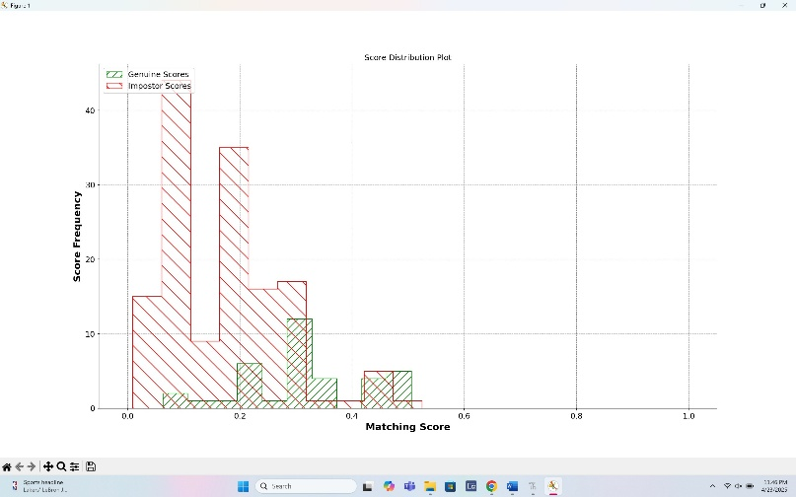
My experiment also examined the impact of disabling the score-level fusion. Without fusion, the system’s error rates were the highest across all conditions. The genuine and impostor score distributions were tightly clustered near low score values, causing significant difficulties in making accurate decisions. This finding highlights how score-level fusion between the KNN and SVM classifiers was crucial for maintaining the system’s robustness. Fusion improved the separation between genuine and impostor scores, even under degraded image conditions like low resolution or severe blurring. By averaging the outputs of both classifiers, the fusion approach created cleaner decision boundaries and enhanced system reliability.

Baseline

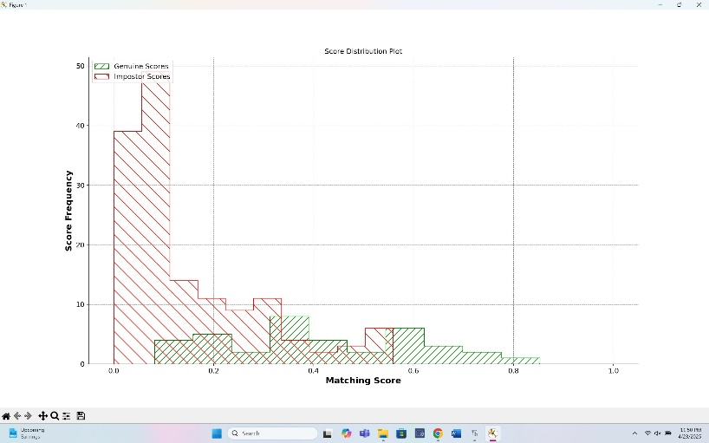

200X200 Resolution

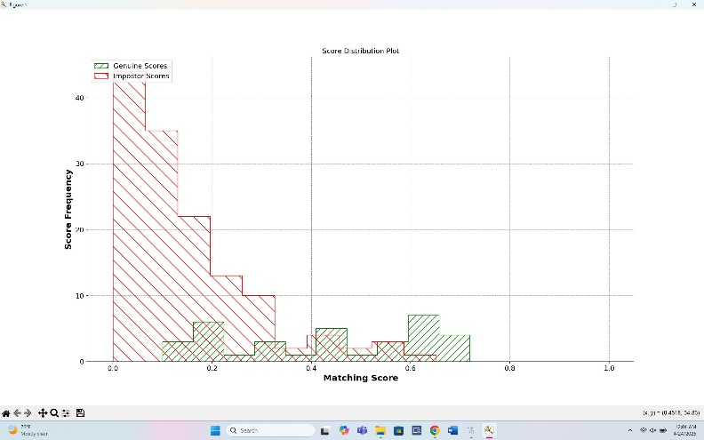

Kernel Size: 7

Ethics Statement
The development and use of biometric systems, especially those involving facial recognition, are associated with important ethical responsibilities due to the potential risks they pose to individual privacy and security. Facial images are highly personal and if mishandled, could lead to serious consequences like identity theft or unauthorized surveillance. Although this project used images from the publicly available Caltech Faces Dataset intended for academic research, it remains essential to acknowledge that any use of biometric data must be handled with care. All image data in this experiment was processed locally, and no information was uploaded or stored in unsecured systems. No personally identifiable information beyond the facial images was included, and in any future application of this system, obtaining clear, informed consent from participants would be mandatory. Consent would need to be voluntary and withdrawable at any time, ensuring participants are fully aware of how their biometric data is used and protected.
Beyond individual privacy risks, biometric systems like facial recognition have broader societal implications. These technologies have raised concerns in the past about disproportionately misidentifying minority groups and enabling mass surveillance. Although this experiment did not assess any demographic based performance disparities due to my dataset’s limitations, it is important to recognize that my design choices like image resolution or classifier combinations can unintentionally affect accuracy rates across different population groups. Future applications of this system must carefully consider fairness, transparency, and the potential impacts on public trust.
To avoid these risks, several strategies should be prioritized in any future work. Biometric data should be stored securely. The best way to do this would be in encrypted access-controlled environments with strong deletion policies to prevent unnecessary retention. Consent protocols must be clear and accessible, outlining how data will be collected, used, and stored, and allowing individuals to revoke consent at any point. Furthermore, it is crucial to audit system performance across different demographic groups to detect and address any unintentional biases. Ensuring fairness, protecting privacy, and maintaining transparency are central to responsibly developing and deploying biometric systems like the one explored in this project.
Conclusion
This project sets out to answer how image resolution and Gaussian blur affect the accuracy of facial recognition systems. The results demonstrated that increasing image resolution improves recognition performance, though benefits are marginal beyond 200×200 pixels. Additionally, applying a modest Gaussian blur, particularly with a kernel size of 7, enhanced system accuracy by reducing image noise and texture inconsistencies, while excessive blurring began to degrade performance. A critical takeaway from these findings is the importance of balancing image clarity and smoothing techniques to optimize facial recognition outcomes. The experiment also confirmed the value of score-level fusion, as combining the outputs of KNN and SVM classifiers significantly improved system robustness under various image conditions. However, limitations of this study include the use of a relatively small, demographically uniform dataset and the exclusion of real-world variables such as varied lighting, facial expressions, and occlusions. Future work should involve testing the system on more diverse datasets, incorporating demographic performance audits, and experimenting with additional image preprocessing techniques and fusion strategies. These steps will help ensure both the technical reliability and ethical responsibility of facial recognition systems moving forward.
References
[1] A. M. Al-Nuimi and G. J. Mohammed, "Face Direction Estimation based on Mediapipe Landmarks," in Proc. 7th Int. Conf. Contemporary Inf. Technol. Math. (ICCITM), Mosul, Iraq, 2021, pp. 185–190, doi: 10.1109/ICCITM53167.2021.9677878.
[2] Y.-Q. Liu, X. Du, H.-L. Shen and S.-J. Chen, "Estimating Generalized Gaussian Blur Kernels for Out-of-Focus Image Deblurring," IEEE Trans. Circuits Syst. Video Technol., vol. 31, no. 3, pp. 829–843, Mar. 2021, doi: 10.1109/TCSVT.2020.2990623.
[3] G. C. Lee, Y.-C. Lee and C.-C. Chiang, "Low-Resolution Face Recognition in Multi-person Indoor Environments Using Convolutional Neural Networks," in Proc. Int. Conf. Comput. Sci. Comput. Intell. (CSCI), Las Vegas, NV, USA, 2021, pp. 1629–1633, doi: 10.1109/CSCI54926.2021.00313.
[4] B. Thaman, T. Cao and N. Caporusso, "Face Mask Detection using MediaPipe Facemesh," in Proc. 45th Jubilee Int. Conv. Inf., Commun. Electron. Technol. (MIPRO), Opatija, Croatia, 2022, pp. 378–382, doi: 10.23919/MIPRO55190.2022.9803531.
[5] A. Matin, F. Mahmud, T. Ahmed and M. S. Ejaz, "Weighted score level fusion of iris and face to identify an individual," in Proc. Int. Conf. Elect., Comput. Commun. Eng. (ECCE), Cox's Bazar, Bangladesh, 2017, pp. 1–4, doi: 10.1109/ECACE.2017.7912868.
[6] https://datacarpentry.github.io/image-processing/06-blurring.html#:~:text=The%20width%20and%20height%20of,a%20dimension%20of%20seven%20pixels.

